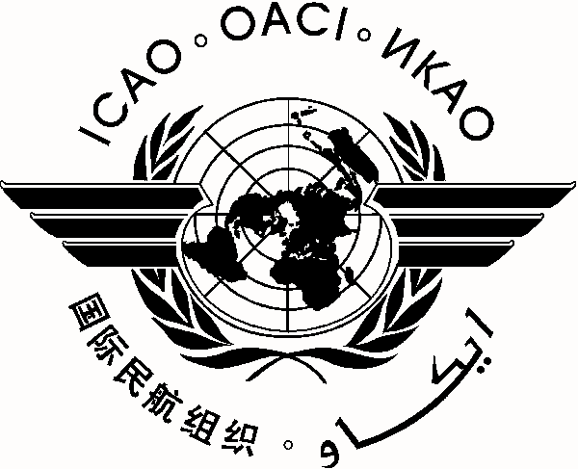 |  | PA-RAST/14/IAT/4
 | International Civil Aviation Organization
 | South American Office (SAM)
 | Fourth Meeting of the Information Analysis Team (IAT/4)/Fourteenth Meeting of the Pan America - Regional Aviation Safety Team (PA-RAST/14)
 | Lima, Peru, 24 to 26 September 2013

Attending:
IAT/4 Meeting  (24 September 2013) |  | PA-RAST/14 Meeting  (25 – 26 September 2013)

REGISTRATION FORM

1. | Name
2. | Position
3. | Organization
4. | Country
5. | Telephone
6. | E-mail

Please send this form to:
E-mail: icaosam@icao.int

